What is Photoshop?

Photoshop is a Graphics Based program from Adobe. this is a Raster Graphic Based imaging tool.
Raster graphics are compromised of a raster (a grid) of small sqaures called pixels. Objects in Photoshop are groups of many pixels - each of which can be a different color. Raster images require more memory and storage than vector images.
This session will introduce you to the tool palette, basic commands, common menus, layers and how to make selections based on shape and color.
User Interface
The user interface, in the industrial design field of human–machine interaction, is the space where interaction between humans and machines (here PHOTOSHOP) occurs. The goal of interaction between a human and a machine at the user interface is effective operation and control of the machine, and feedback from the machine which aids the operator in making operational decisions.
You can see in Photoshop UI there are 5 main modules available see the Picture below
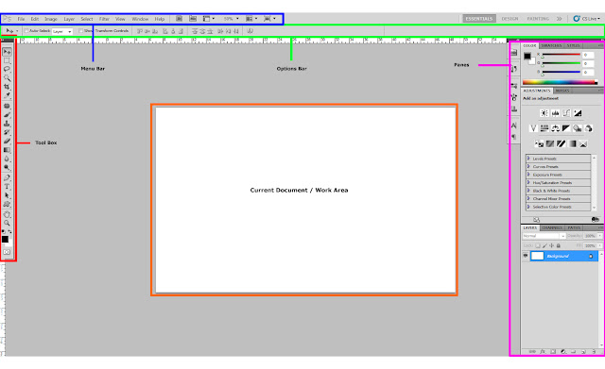
Tool Palate/Tool Box
Perhaps the most important element of the Photoshop interface is the toolbar. It contains a bunch of icons that represent the different tools Photoshop offers to alter and create images. These include tools for selecting specific areas of images, changing the colors of the image, stretching, transforming, and erasing parts of an image, and many more. To get an idea of what some of these tools can do, mouse over the icons and you’ll get an explanatory tool tip. I’ll explain some specific tools in the following sections of this tutorial.
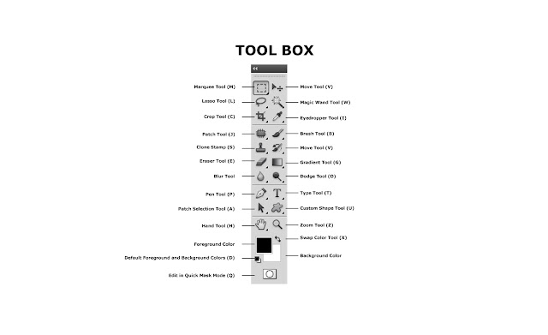

Panes
Panes are also important features of the Photoshop interface. All sorts of information is displayed in these panes, and therefore they can get a little confusing. They display location information, tool options, and history, among other things. If you ever lose track of a specific pane (they tend to stack up), go to the windows menu and select that pane to view it.
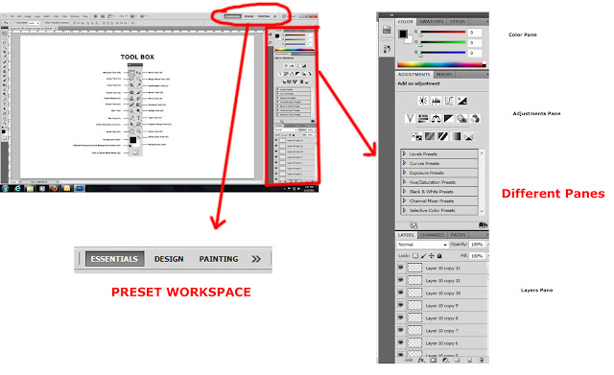

MENU
Menus are probably the most familiar interface elements to a new Photoshop user. They contain all sorts of options, but since there are not as visible as panes or the toolbar, they are often only partially explored. I’ll take time right now to go over the menus and give a brief description to orient you to each.

- File contains all of the stuff you’d expect it to, with a few extras including Import, which deals with scanning, and Save for Web, which allows you to export a web-ready image from your Photoshop file.
- Edit is another familiar menu. In Photoshop, edit houses all of the expected options as well as Fill & Stroke, and other image-altering functions.
- Items on the Image menu effect a whole image, for the most part. Here you’ll find color adjustments, size adjustments, and any other changes you need to make globally when working with a Photoshop file.
- The layer menu is similar to the image menu, but it contains options that effect only current or selected layers. I’ll explain layers a little later, but for now, just understand that an image in Photoshop consists of stacked transparent layers; options in the Layer menu affect these pieces of the image rather than the complete image.
- The select menu deals with selections you make. Selecting the specific parts of an image you’d like to alter is a difficult part of working in Photoshop. This menu gives you some options regarding selections, including the ability to save selections, reverse them, or add to them. Learning the options on the selection menu can really save you some time.
- The filter menu is probably what most people think about when they think about Photoshop. The filter menu allows you to apply filters to any part of your image. These filters include ways to change the texture of the image, with some potentially radical results.
- The view menu is where you change the view settings. You can use this to show and display guidelines on the image, and to zoom in and out, among other things.
- The window menu allows you to toggle back and forth between hide and show for each interface element. This is the first place you should go if you lose track of a particular window while you’re working.
- Last and least, of course, is the help menu. The help documentation isn’t so helpful, but for some reason, this menu contains two nice features: resize image, and export transparent image, which I’ll get to later.
OPTIONS BAR
The options bar, which is located directly underneath the menus, is a useful tool when working with the different Photoshop tools. As you can see right now, when the selection tool is in use, the options bar reflects the changes that can be made to how that specific tool operates. Here, you have selection options, and style options, which includes the ability to make the selection tool a specific size in pixels. When you switch tools, to the paintbrush tool for instance, these options change. When a tool in Photoshop isn't behaving as you expect it to, the options bar should be the first place you look to fix it.
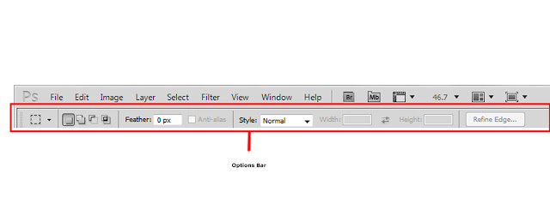
These are the Basic UI (User Interface) Elements of the Photoshop.
With the Next chapter we will study about Different File formats, Creating A New Document, Saving a New Document and Playing with Layers.

